**4**

0000

**UNIT**

**ADDITION OF NUMBERS WITH SUMS NOT GREATER THAN 100, SUBTRACTION OF NUMBERS WITH MINUENDS NOT GREATER THAN 100**

**Grade – level indicators:**

1. Add, subtract and mix addition and subtraction of cardinal numbers not exceeding 100, and 0, as well as be aware of the validity of the answers. (MA1. 2 Gr 1/1)

2. Analyse and find answers to problems and mix-problem of cardinal numbers not exceeding 100, and 0, as well as be aware of the validity of the answers. (MA6. 1 Gr 1/1)

3. Apply diverse methods for problem-solving. (MA6. 1 Gr 1/1)

4. Appropriately apply mathematical knowledge, skills and processes for problem-solving. (MA6.1 Gr 1/2)

5. Suitably provide reasoning for decision-making and appropriately present the conclusion. (MA6. 1 Gr 1/3)

6. Accurately use mathematical language and symbols for communication, communication of concepts and presentation. (MA6. 1 Gr 1/4)

1. Link various bodies of mathematical knowledge, and link mathematics with other disciplines. (MA6. 1 Gr 1/5)

**Diagram of learning contents:**

Addition of two-digit numbers and one-digit numbers

Subtraction of two-digit numbers and 10, 20, 30,… 90

Word problems on addition

Addition of two numbers with sums not greater than 100

Subtraction of numbers with minuends not greater than 100

Addition of two-digit numbers and two-digit numbers

Subtraction of two-digit numbers and one-digit numbers

Addition of two-digit numbers and 10, 20, 30,…,90

Relationship between addition and subtraction

Subtraction of two-digit numbers and two-digit numbers

Creating word problems from pictures

Word problems

Combination of addition and subtraction

Word problems on addition and subtraction

Addition of two numbers with sums not greater than 100

1.

Addition of two-digit numbers and one-digit numbers

1.1

Pom had 24 baht. He got 5 baht more. How much money has Pom got in total?







= 29

= 20 + (4 + 5)

24 + 5 = 20 + 4 + 5

Method 1: Expand the two-digit numbers and find the sums

The answer can be found by following methods;

24 + 5 = 

= 20 + 9

Method 2: Doing vertical addition

|  |  |
| --- | --- |
| Tens | Ones |
| 2 | 4  +  5 |
| 2 | 9 |

|  |
| --- |
| 2 4 |
| 5 |
| 2 9 |

+

OR

Answer Pum has got a total of 29 (๒๙) baht.

Addition of two-digit numbers and one-digit numbers is done by adding the numbers according to their places.

A candy shop sold 32 candies. Later, 4 more candies were sold. How many candies did the shop sell in total?



10

10

10

32 + 4 = 

= 36

= 30 + (2 + 4)

32 + 4 = 30 + 2 + 4

The answer can be found by following methods;

Method 1: Expand the two-digit numbers and find the sum

= 30 + 6

Method 2: Doing vertical addition

|  |  |
| --- | --- |
| Tens | Ones |
| 3 | 2  +  4 |
| 3 | 6 |

|  |
| --- |
| 3 2 |
| 4 |
| 3 6 |

+

OR

Answer The candy shop has sold a total of 36 (๓๖) candies.

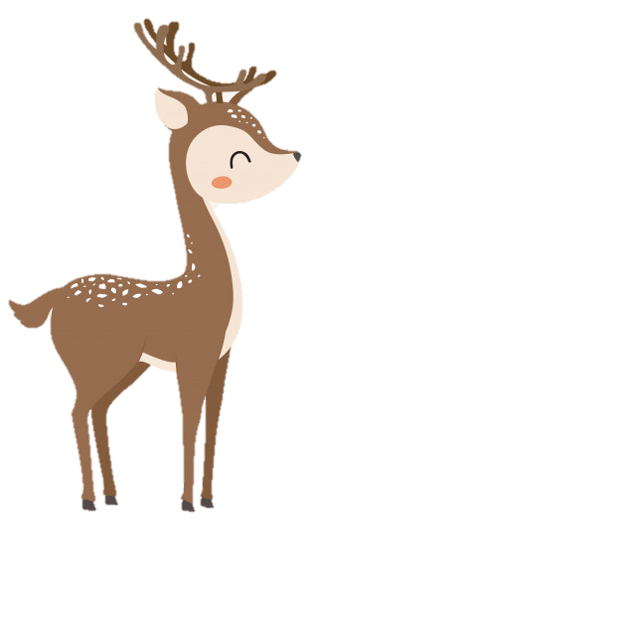

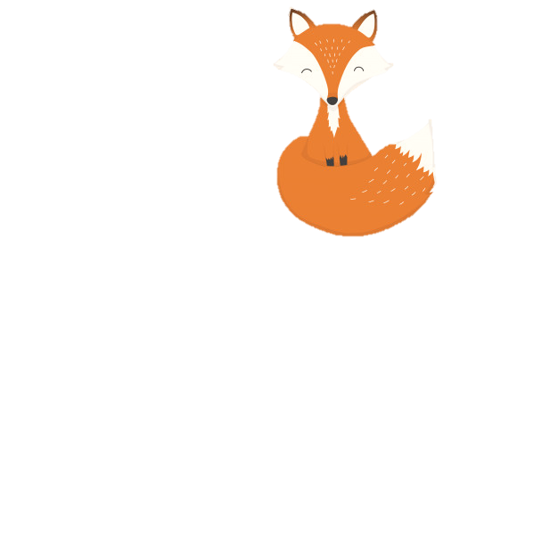

Fill numbers in the . (Work in your notebook)

1.



1)

10

10

10

10

10



54 + 5 = 50 + + = + =

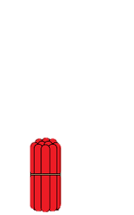

2)



75 + 2 = + + = + =



3)



27 + 1 = + + = + =

Find the sums. (Work in your notebook)

2.

|  |  |
| --- | --- |
| Tens | Ones |
| 5 | 2  +  3 |

1)

52 + 3

|  |  |
| --- | --- |
| Tens | Ones |
| 4 | 7  +  2 |

2)

47 + 2

38 + 1

3)

|  |  |
| --- | --- |
| Tens | Ones |
| 3 | 8  +  1 |

|  |  |
| --- | --- |
| Tens | Ones |
| 2 | 6  +  3 |

26 + 3

4)

|  |  |
| --- | --- |
| Tens | Ones |
| 7 | 1  +  5 |

71 + 5

5)

|  |
| --- |
| 3 2  +  7 |

|  |
| --- |
| 8 7  +  2 |

|  |
| --- |
| 6 5  +  3 |

8)

7)

6)

|  |
| --- |
| 1 8  +  1 |

|  |
| --- |
| 9 2  +  4 |

11)

10)

9)

|  |
| --- |
| 7 3  +  6 |

|  |
| --- |
| 5 5  +  2 |

|  |
| --- |
| 7 0  +  9 |

|  |
| --- |
| 3 4  +  5 |

14)

13)

12)

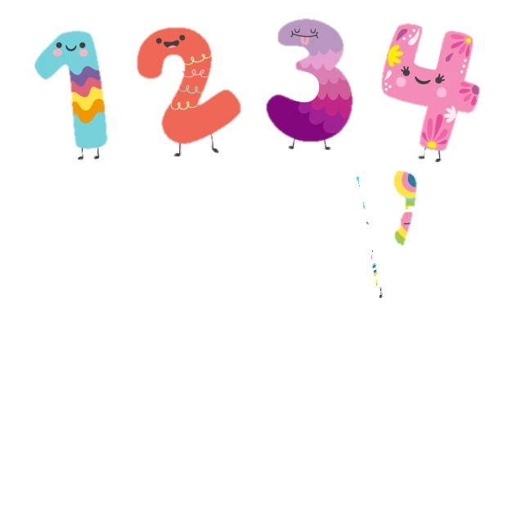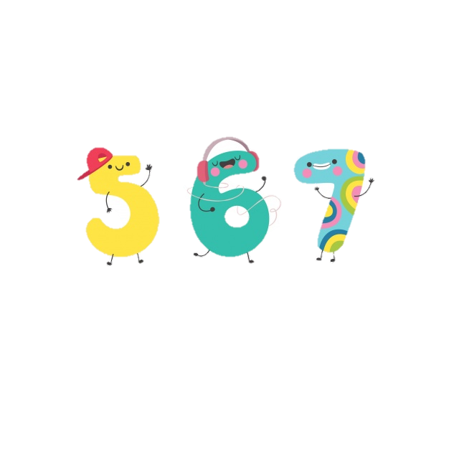

Addition of two-digit numbers and 10, 20, 30, …… , 90

1.2

A brother had 35 marbles. Later, he got additional 10 marbles. How many marbles does he have in total?







35 + 10 = 30 + 5 + 10

Method 1: Expand the two-digit numbers and find the sums

The answer can be found by following methods;

35 + 10 = 

Add numbers according to their places.

= (30 + 10) + 5

= 40 + 5



= 45

Method 2: Doing vertical addition

|  |
| --- |
| 3 5  + |
| 1 0 |
| 4 5 |

|  |  |
| --- | --- |
| Tens | Ones |
| 3  1 | 5  +  0 |
| 4 | 5 |

Answer He has a total of 45 (๔๕) crystals.

35 + 10 = 45

Addition of two-digit numbers and 10, 20, 30, …… , 90 is done by adding the numbers according to their places.

Fill numbers in the . (Work in your notebook)

1.



1)



48 + 30 = 70 + =



2)



55 + 20 = + =



3)



30 + 21 = + =





4)





40 + 56 = + =

Find the sums. (Work in your notebook)

2.

|  |  |
| --- | --- |
| Tens | Ones |
| 3  3 | 7  +  0 |

|  |  |
| --- | --- |
| Tens | Ones |
| 5  2 | 0  +  8 |



1)

2)



|  |
| --- |
| 2 5  +  5 0 |

|  |
| --- |
| 4 0  3 4 |

|  |
| --- |
| 2 5  +  5 0 |

|  |
| --- |
| 2 5  +  5 0 |

|  |
| --- |
| 2 5  +  5 0 |

6)

5)

+

4)

3)

Addition of two-digit numbers and two-digit numbers

1.3

Sister saves 31 baht. Her brother saves 23 baht. How much money do the sister and the brother save altogether?





31 + 23 = 

The answer can be found by following methods;

Method 2: Doing vertical addition

Method 1: Expand the two-digit numbers and find the sums

|  |
| --- |
| 3 1  +  2 3 |

|  |  |
| --- | --- |
| Tens | Ones |
| 3  2 | 5  +  3 |
| 5 | 4 |

+

|  |
| --- |
| 3 0 + 1  2 0 + 3 |

|  |
| --- |
| 3 1  +  2 3 |
| 5 4 |

OR

31 + 23 = 50 + 4 = 54

31 + 23 = 54

Answer The total money the sister and the brother save is 54 (๕๔) baht.

Addition of two-digit numbers and two-digit numbers is done by adding the numbers according to their places.

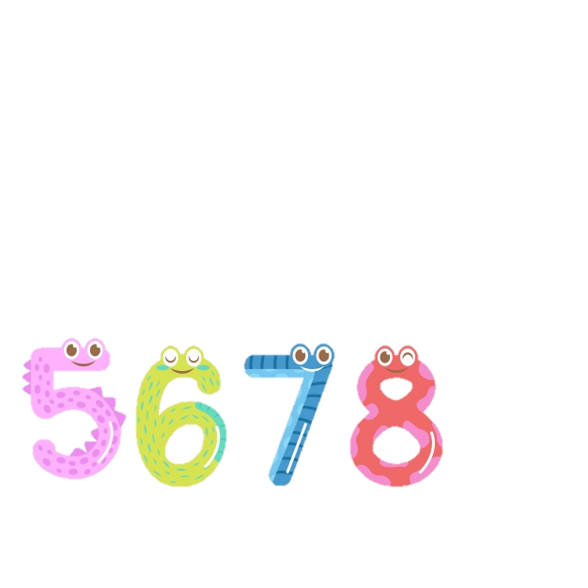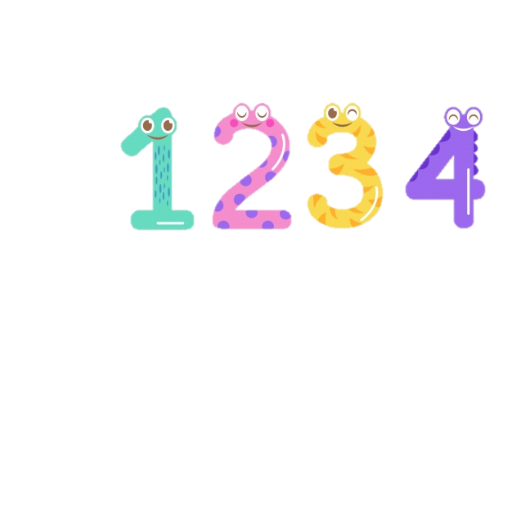

Find the sums. (Work in your notebook)

1.

|  |  |
| --- | --- |
| Tens | Ones |
| 3  6 | 4  +  3 |

********

1)



|  |  |
| --- | --- |
| Tens | Ones |
| 5  2 | 1  +  5 |



2)





|  |
| --- |
| 2 8  3)  +  2 1 |

|  |
| --- |
| 3 7  +  4 0 |

|  |
| --- |
| 8 1  +  1 7 |

5)

4)



|  |
| --- |
| 4 4  +  5 1 |

|  |
| --- |
| 3 5  8)  +  5 4 |

|  |
| --- |
| 7 1  +  1 3 |

7)

6)



|  |
| --- |
| 4 5  +  3 2 |

|  |
| --- |
| 5 6  10)  +  2 2 |

|  |
| --- |
| 2 4  +  6 3 |

11)

9)

Find the sums. (Work in your notebook)

2.

2) 25 + 32 = 

1) 46 + 22 = 

3) 67 + 20 = 

4) 30 + 59 = 

5) 28 + 41 = 

6) 21 + 38 = 

7) 22 + 65 = 

8) 24 + 40 = 

10) 43 + 54 = 

9) 72 + 17 = 

Word problems on addition

2.

1. Clarifying the problem

1. Planning
2. Doing
3. checking

Oy saved 36 baht. Her father gave her additional 20 baht. How much money does Oy have in total?

**Steps in solving word problems**

1) Oy saved 36 baht.

2) Her father gave her 20 baht.

* What is given?
* What is asked?

How much money does Oy have in total?

Oy got additional money from her father. So Oy has more money. Addition should be used.

36 + 20 = 



1. The sum, 56, is greater than 36 or 20. So the answer is reasonable.

2. Use the relationship between addition and subtraction;

56 - 20 = 36

Therefore, the answer is correct.

Answer Oy has 56 (๕๖) baht in total.

36 + 20 = 56

Orally state the sentences that show the given information and the questions asked.

1.

1. One bunch of longans has 42 longans. Another bunch has 46 longans. How many longans of the two brunches are there?
2. There are 21 boy students and 17 girl students in class 1/1. How many students are there in the class?
3. In my mathematic workbook, I counted 25 stars. In my Thai language workbook, I counted 24 stars. How stars have I got altogether?
4. There were 37 tennis balls in the bascket. Another 22 tennis balls were added. How many tennis balls are there in the basket at the moment?
5. I bought food for 23 baht and I have left 16 baht. How much money did I have before buying the food

Write in mathematical sentences and find the answers. (Work in your notebook)

2.

1. A worker laid 48 tiles in the kitchen. Another 20 tiles will be lain. How many tiles will be used in total
2. The supermarket sold 36 big bottles and 12 small bottles of water. How many bottles of water were sold in total?
3. I read 14 pages of a book. There are 15 unread pages left. How many pages of this book are there?

|  |  |  |
| --- | --- | --- |
| 7 | 2 | 3 |
|  |  | 8 |
| 5 | 6 |  |

**Fill the correct numbers in the blanks to get the sums of 12 out of the horizontal and vertical addition.**

+

1. There are 27 people doing aerobic dancing. There are 22 more people doing Chinese dancing than those who are doing aerobic dancing. How many people are doing Chinese dancing?
2. Auntie Sri has 40 green mangoes. She has 27 ripe mangoes more than the green ones. How many ripe mangoes does she have?
3. There were 51 students reading books in the library. Another 8 students walked into the library. How many students are there in the library?
4. A teacher prepared 23 sheets of red paper and 25 sheets of blue paper. How many sheets of coloured paper did the teacher prepared?
5. A shop sold 6 shirts. There are 32 shirts left. How many shirts did the shop have before selling them?
6. A cook wants 63 chicken eggs and 26 duck eggs. How many eggs altogether does the cook want?
7. A seller made 25 boxes of rice and boiled eggs. He also made 14 boxes of rice and chicken curry. How many

boxes of rice did he make in total?

**LET’S TRY!**

Subtraction of numbers with minuends not greater than 100

3.

Subtraction of two-digit numbers and one-digit numbers

3.1

Win had 26 baht. He spent 5 baht buying some sweets. How much money has he left?





26 - 5 = 

The answer can be found by the following methods;

Method 2: Doing vertical addition

Method 1: Expand the two-digit numbers and find the sums

|  |  |
| --- | --- |
| Tens | Ones |
| 2 | 6  –  5 |
| 2 | 1 |

26 – 23 = 20 + 6 – 5

|  |
| --- |
| 2 6  –  5 |
| 2 1 |

= 20 + ( 6 – 5 )

OR

= 20 + 1

= 21

26 – 5 = 21

Answer The total money she has, is 21 baht coins.

Subtraction of two-digit numbers and one-digit numbers is done by subtracting the numbers according to their places.

There was 37 eggs. 4 eggs broke. How many eggs are left?





37 – 4 = 

The answer can be found by the following methods;

Method 1: Expand the two-digit numbers and find the differences

Method 2: Doing vertical subtraction

|  |  |
| --- | --- |
| Tens | Ones |
| 3 | 7  –  4 |
| 3 | 3 |

37 – 4 = 30 + 7 – 4

|  |
| --- |
| 3 7  4 |
| 3 3 |

= 30 + ( 7 – 4 )

–

OR

= 30 + 3

= 33

37 – 4 = 33

Answer There are 33 (๓๓) eggs left.

Find the differences. (Work in your notebook)

1.

1)

|  |  |
| --- | --- |
| Tens | Ones |
| 3 | 3  –  1 |



2)

|  |  |
| --- | --- |
| Tens | Ones |
| 3 | 3  –  1 |



3)

|  |  |
| --- | --- |
| Tens | Ones |
| 2 | 4  –  3 |



10

10



|  |
| --- |
| 5 3  –  2 |

|  |
| --- |
| 3 1  6)  –  1 |

|  |
| --- |
| 2 9  –  6 |

5)

4)



|  |
| --- |
| 7 8  –    3 |

|  |
| --- |
| 9 7  –  5 |

|  |
| --- |
| 8 6  7)  –  2 |

8)

9)

Find the differences. (Work in your notebook)

2.

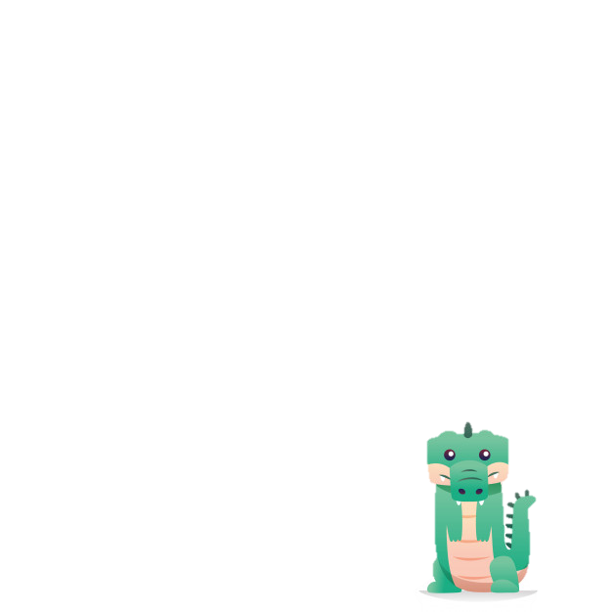

2) 44 – 1 = 

1) 25 – 2 = 

4) 76 – 3 = 

3) 87 – 4 = 

6) 57 – 2 = 

5) 69 – 5 = 

Subtraction of two-digit numbers and 10, 20, 30, ...., 90

3.2

A sister had 25 candies. She gave 10 candies to her brother. How many candies has the sister left?



10

10

25 – 10 = 

The answer can be found by the following methods;

Method 2: Doing vertical subtraction

Method 1: Expand the two-digit numbers and find the differences

|  |
| --- |
| 2 5  –  1 0 |

|  |  |
| --- | --- |
| Tens | Ones |
| 2  1 | 5  –  0 |
| 1 | 5 |

–

|  |
| --- |
| 2 0 + 5  1 0 + 0 |

|  |
| --- |
| 2 5  –  1 0 |
| 1 5 |

OR

25 – 10 = 10 + 5 = 15

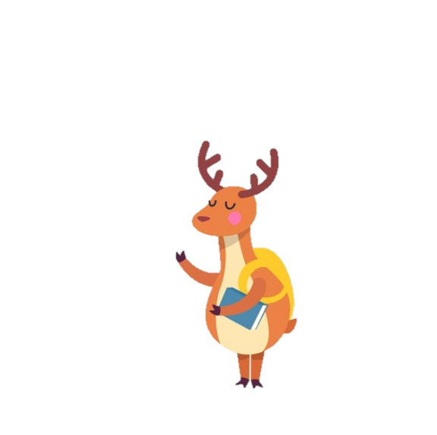

Subtract zero from any numbers gets that same numbers.

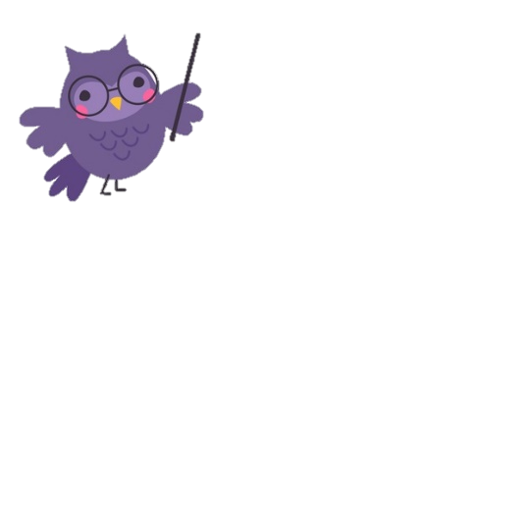

Subtract numbers according to their places.

25 – 10 = 15

Answer She has left 15 (๑๕) candies.

Find the differences. (Work in your notebook)

1.

1)

|  |  |
| --- | --- |
| Tens | Ones |
| 5  3 | 2  –  0 |



2)

|  |  |
| --- | --- |
| Tens | Ones |
| 6  4 | 3  –  0 |



|  |  |
| --- | --- |
| Tens | Ones |
| 3  1 | 1  –  0 |



10

10

3)

10

10



|  |
| --- |
| 3 2  –  2 0 |

|  |
| --- |
| 5 4  6)  –  3 0 |

|  |
| --- |
| 2 1  –  1 0 |

5)

4)



|  |
| --- |
| 4 5  –    1 0 |

|  |
| --- |
| 8 3  –  5 0 |

|  |
| --- |
| 6 6  7)  –  3 0 |

8)

9)



|  |
| --- |
| 9 8  –    7 0 |

|  |
| --- |
| 7 5  –  4 0 |

|  |
| --- |
| 4 4  –  3 0 |

11)

10)

12)

Find the differences. (Work in your notebook)

2.

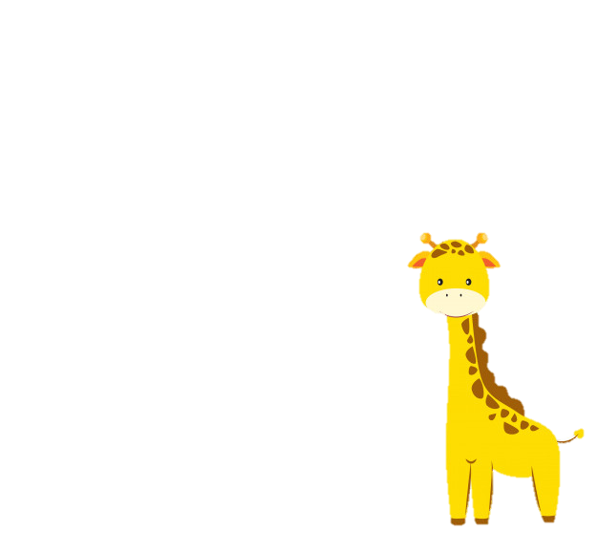

2) 67 – 20 = 

1) 26 – 10 = 

4) 92 – 50 = 

3) 51 – 40 = 

6) 43 – 30 = 

5) 88 – 60 = 

Subtraction of two-digit numbers and two-digit numbers

3.3

There were 28 pencils. 12 pencils were sold. How many pencils are left?

Subtract numbers that are in same places.



28 – 12 = 

The answer can be found by the following methods;

Method 2: Doing vertical subtraction

Method 1: Expand the two-digit numbers and find the differences

|  |
| --- |
| 2 8  –  1 2 |

|  |  |
| --- | --- |
| Tens | Ones |
| 2  1 | 8  –  2 |
| 1 | 6 |

–

|  |
| --- |
| 2 0 + 8  1 0 + 2 |

|  |
| --- |
| 2 5  –  1 0 |
| 1 5 |

OR

28 – 12 = 10 + 6 = 16

28 – 12 = 16

Answer There are pencils 16 (๑๖ ) left.

Find the differences. (Work in your notebook)

1.

|  |  |
| --- | --- |
| Tens | Ones |
| 5  3 | 6  –  4 |



1)



2)

|  |  |
| --- | --- |
| Tens | Ones |
| 3  1 | 4  –  1 |



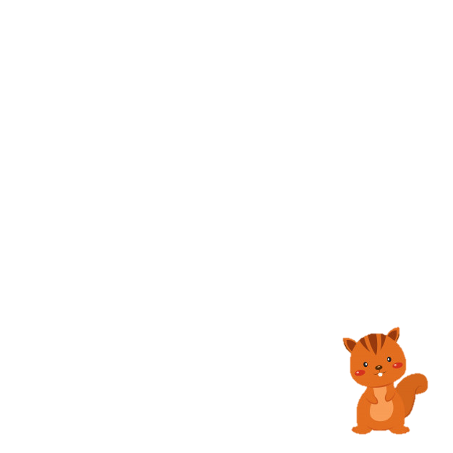

Find the differences. (Work in your notebook)

2.

4**)**

3**)**

1**)**

2**)**

|  |
| --- |
| 3 8  –  2 5 |

|  |
| --- |
| 8 9  –  5 5 |

|  |
| --- |
| 7 3  –  2 1 |

|  |
| --- |
| 6 7  –  3 2 |

8**)**

7**)**

6**)**

5**)**

|  |
| --- |
| 5 5  –  1 4 |

|  |
| --- |
| 7 4  –  4 2 |

|  |
| --- |
| 4 6  –  1 3 |

|  |
| --- |
| 6 8  –  4 4 |

|  |
| --- |
| 8 7  –  6 5 |

|  |
| --- |
| 4 7  –  2 3 |

12**)**

11**)**

10**)**

9**)**

|  |
| --- |
| 8 4  –  4 1 |

|  |
| --- |
| 9 9  –  6 6 |

94 – 21 = 

14**)**

28 – 13 = 

13**)**

35 – 23 = 

79 – 36 = 

16**)**

15**)**

56 – 12 = 

97 – 54 = 

18**)**

17**)**

Find the differences. (Work in your notebook)

3.

2) 66 – 4 = 

1) 36 – 3 = 

4) 87 – 42 = 

3) 23 – 20 = 

6) 37 – 13 = 

5) 59 – 17 = 

8) 51 – 21 = 

7) 49 – 6 = 

10) 48 – 18 = 

9) 67 – 25 = 

12) 56 – 14 = 

11) 99 – 89 = 

14) 60 – 20 = 

13) 74 – 53 = 

Relationship between addition and subtraction

4.



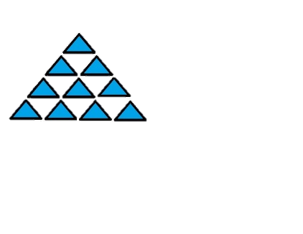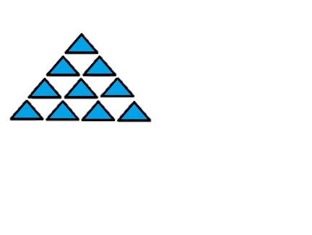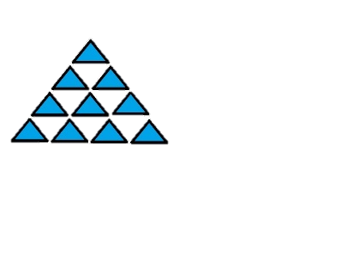



32

21

The above picture have the total of 53 and shapes.

There are 21 and 32 .

It can be written in a mathematical sentence as;

53 – 21 = 32

When 53 is minuend, 21 is the subtrahend and 32 is the difference.

Applying the relationship of the difference plus subtrahend gives minuend;

Changing the order of augend and addend does not change the sums.

Therefore,

32 + 21 = 53

21 + 32 = 53

or

From the above picture, mathematical sentences showing the relationship between addition and subtraction can be written as follows;

********

45

34

34 + 45 = 79

45 + 34 = 79

79 – 45 = 34

79 – 34 = 45

Write all of the mathematical sentences showing the relationship between addition and subtraction. (Work in your notebook)

1.

1)





10

10

10

10

2)



2.

Fill correct numbers in the using the relationship between addition and subtraction. (Work in your notebook)

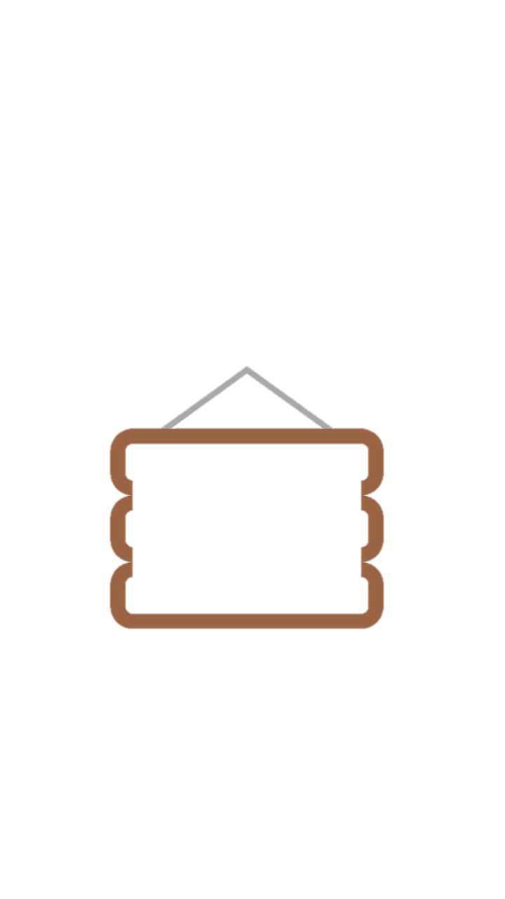

2) 35 – 4 = 

1) 20 + 12 = 

 – 12 = 20

 + 4 = 20



3) 47 – 23 = 

4) 26 + 22 = 

 + 23 = 47

 – 22 = 26



5) 24 + 32 = 

6) 69 – 25 = 

 – 32 = 24

 + 25 = 69



Word problems

5.

1. Clarifying the problem

1. Planning
2. Doing
3. checking

Mother fried 45 chicken balls. She put 12 chicken balls on a plate. How many chicken balls are left in the pan?

**Steps in solving word problems**

1) Mother fried 45 chicken balls.

2) 12 chicken balls were put on a plate

* What is given?
* What is asked?

How many chicken balls are left in the pan?

The chicken balls were taken out of the pan, so the number left in the pan should be fewer.

Subtraction is used.

45 – 12 = 

45 – 12 = 33

Answer The number of chicken balls left in the pan is 33 (๓๓).

1. The difference, 33, is smaller than 45. So it is reasonable.

2. Use the relationship between addition and subtraction;

33 + 12 = 45

Therefore, the answer is correct.



Orally state the sentences that show the given information and the questions asked.

1.

1. There are 38 students in the class ½. 3 of them did not come to school today. How many students are there in class today?
2. There are 55 teachers in Dekdee kindergarten school. There are 11 male teachers. How many female teachers are there in the school?
3. There are 81 people attending the seminar. But there are only 70 glasses. How many more glasses are needed in order that everyone in the seminar is served?
4. A mother had 50 baht. She spent 40 baht buying rose and apples. How much money has the mother left?
5. Pim wants to give out 29 notebooks. She has already had 16 notebooks. How many additional notebooks does she need to find?

Write in mathematical sentences and find the answers. (Work in your notebook)

2.



1) A grandmother bought 39 sweets. She gave 21 sweets to her neighbours. How many sweets are left?

2) A grandfather is 64 years old. A grandmother is 61 years old. How many years is the grandmother younger than the grandfather?

3) I saved 84 baht. My sister saved 24 baht less than I did. How much money did my sister save?

4) A book has 45 pages. 32 pages were read. How many unread pages are left?

5) My sister and her friends bought 55 blankets. They gave 34 blankets to local people. How many blankets are left?

6) A doll bear costs 96 baht. A doll dog costs 81 baht. How much does a doll bear cost more than a doll dog?

7) A school invited 66 parents to attend the meeting. 55 parents came. How many parents missed the meeting?

8) A sister prepared 98 glasses of drinking water. 42 glasses were drunk. How many glasses of drinking are left?

9) A restaurant cooked 29 boiled eggs and 17 fried eggs. How many boiled eggs are there more than fried eggs?

10) A group of 59 tourists consists of 43 females. How many males are there in the group?

**LET’S TRY!**



**What are the missing numbers?**



**9 2 7 4 5**



**1 8 3 6 5**

Word problems on addition and subtraction

6.

Write in mathematical sentences and find the answers. (Work in your notebook)

My sister bought a 25 baht pen and 33 baht notebook. How much money did she pay in total?

1

The merchant had 49 papayas. He sold 26 of the papayas. How many papayas are left?

2

The library has 43 comic books. It requires to have 95 comic books in the library. How many comic books does the library need to find?

3

My father read 32 pages of a book. There are 67 unread pages. How many pages does the book have?

4

6

The first comic book has 24 pages. The second one has 13 pages more than the first one. How many pages does the second comic book have?

There are 57 monkeys and 45 gibbons. How many gibbons are there fewer than monkeys?

5

A merchant sold 23 durians. She still has left 36 durians. How many durians did she have before selling them?

7

A shirt costs 99 baht and a pair of pants cost 79 baht. How much does the shirt cost more than the pair of pants?

8

Mother bought 25 bars of white chocolate and 14 bars of dark chocolate. How many bars of dark chocolate did she buy fewer than bars of white chocolate?

9

Under Siri wants 47 flower pots. He has already had 12 pots. How many more pots does he have to buy?

10

A father is 34 years old. The grandfather is 30 years older than the father. How old is the grandfather?

11

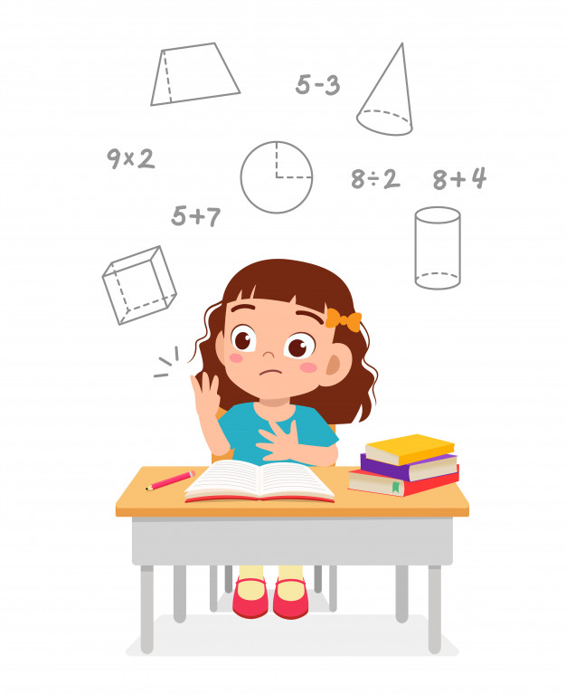

Combination of addition and subtraction

7.

9 – (6 – 2) = 

(4 + 5) – 1 = 

In the case when several numbers are added or subtracted, the result of numbers in the brackets must be found first. Then it is added to or minus by the rest.

9 – (6 – 2) = 9 – 4

= 5

(4 + 5) – 1 = 9 – 1

= 8

Fill missing numbers in the . (Work in your notebook)

1.

1. ( 7 – 3 ) – 2 =  – 2

= 

1. 5 – ( 4 + 1 ) = 5 – 

= 

= 

= 

1. 19 – ( 8 – 3 ) = 57 – 

= 

= 

= 

1. 19 – ( 8 – 3 ) =  – 25
2. 19 – ( 8 – 3 ) = 19 – 
3. 80 – ( 60 + 20 ) = 80 – 
4. 10 + ( 60 + 20 ) = 10 + 

Fill missing numbers in the . (Work in your notebook)

2.

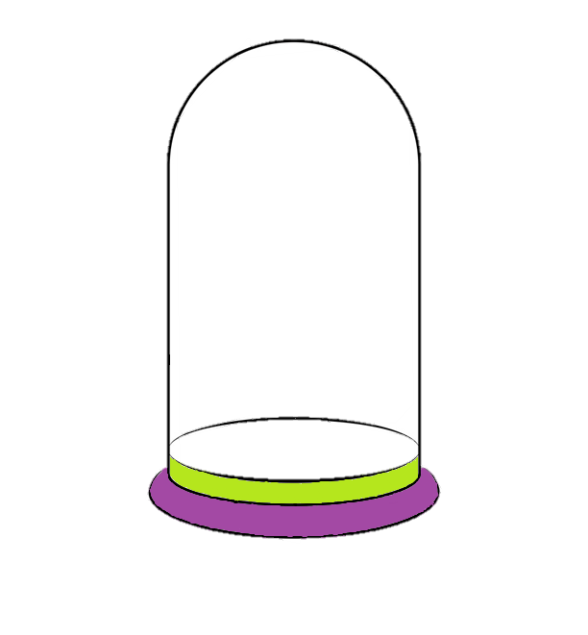

+

|  |
| --- |
| 4 0  +  3 0 |
| +  2 0 |

|  |
| --- |
| 3 0  2 0 |
| 5 0  –  1 0 |

|  |
| --- |
| 8 0  –  5 0 |
| +  4 0 |



40



|  |
| --- |
| 2 3  +  4 5 |
| –  3 6 |

|  |
| --- |
| 6 4  +  1 5 |
| –  4 7 |

|  |
| --- |
| 5 4  –  3 2 |
| +  1 3 |



|  |
| --- |
| 7 6  –  4 5 |
| –  1 1 |

|  |
| --- |
| 8 8  –  3 0 |
| –  7 |

|  |
| --- |
| 2 1  +  1 3 |
| +  5 |



Word problems on combination of addition and subtraction

8.

Finding the answers of word problems on combination of addition and subtraction

8.1

Mother boiled 5 eggs. Father ate 1 boiled egg and Ko ate 2 boiled eggs. How many eggs are left?

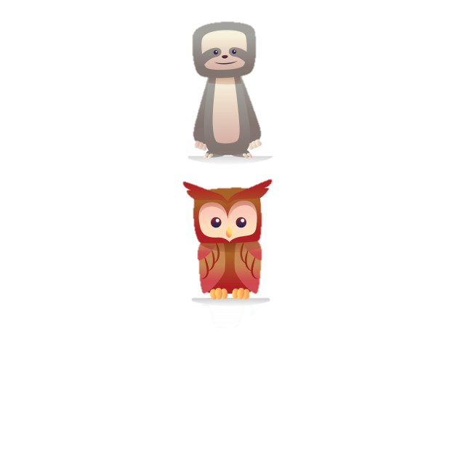

Method 1

Find the number of boiled eggs left after the father ate first, then minus by number of boiled eggs eaten by Ko.

( 5 – 1 ) – 2 = 

Mathematical sentence;

( 5 – 1 ) – 2 = 4 – 2



Method 2:

= 2

Add the numbers of boiled eggs eaten by father and Ko. Then subtract the sum from the total number of boiled eggs.

( 5 – 1 ) – 2 = 

Mathematical sentence;

( 5 – 1 ) – 2 = 4 – 2

= 2

To find the answers in word problems on combination of addition and subtraction, find the results of the numbers in the brackets before adding to or minus by the remaining number.

From the following word problems, write mathematical sentences with brackets. (Work in your notebook)

1

Nid had 1 new unsharpened pencil. Her mother bought her another 3 new pencils. Nid sharpened 2 pencils. How many unsharpened pencils are left?

2

Emmy had 8 cookies. She gave 3 cookies to her elder sister and 2 to her young brother. How many cookies has Emmy left?

Solving word problems on combination of addition and subtraction

8.2

1. Clarifying the problem

1. Planning
2. Doing
3. Checking

**Example**

Moe cut 35 red roses and 10 pink roses. She sold 23 cut roses. How many cut roses has she left?

**Steps in solving word problems**

1) Moe cut roses

2) Moe cut 35 red roses and 10 pink roses.

3) Moe sold 23 cut roses.

* What is given?
* What is asked?

How many chicken cut roses has she left?

Firstly, addition is used to find the total number of cut roses. Then subtraction is used to find the number of cut roses left after selling.

( 35 + 10 ) – 23 = 

( 35 + 10 ) – 23 = 45 – 23

= 22

Answer Moe has left 22 (๒๒) cut roses.

The answer, 22, is correct; because 22 + 23 = 45.

1. Clarifying the problem

1. Planning
2. Doing
3. Checking

**Example**

A shop had 26 bottles of milk. 15 bottles were sold. The shop bought additional 48 bottles of milk. How many bottles of milk has the shop left?

**Steps in solving word problems**

1) The shop had 26 bottles of milk.

2) 15 bottles of milk were sold.

3) 48 additional bottles of milk were bought.

* What is given?

How many bottles of milk has the shop left?

* What is asked?

Firstly, subtraction is used to find how many bottles are left after selling them. Then addition is used to find how many bottles they have after buying some more.

( 26 – 15 ) + 48 = 

( 26 – 15 ) + 48 = 11 + 48

= 59

Answer There are 59 (๓๙) bottles of milk left in the shop.

The answer, 59, is correct; because59 – 48 = 11.

From the following word problems, write mathematical sentences and find the answers. (Work in your notebook)

There were 25 fresh eggs. 5 eggs were boiled and 10 were fried. How many fresh eggs are left after cooking?

1

Yesterday Ann read 10 pages of a book. Today she read another 6 pages. There are 32 unread pages of the book have?

2

There were 21 passengers on a bus and 3 passengers got on the bus. Later 12 passengers got off the bus. How many passengers are there on the bus now?

3

There is a combination of 65 oranges, mangosteens and rambutans in a basket. Among the fruits, 4 are oranges and 30 are rambutans. How many mangosteens are there in the basket?

4

Joy had 12 notebooks. She gave 2 notebooks to her sister. Joy bought additional 3 notebooks. Now how many notebooks does Joy have?

5

Ood had 8 baht. Then he was given 11 baht from his mother and 20 baht from his father that gave him the exact amount of money to buy a pencil case. How much did the pencil case cost?

6

There was 15 students doing their homework at a table. Later on, 4 more students joined them and then 2 went home. How many students remain at the table?

7

Pom paid 20 baht for fried rice and 5 baht for drinking water. She has left 12 baht. How much money did she have before spending any?

8

Creating word problems with pictures

9.

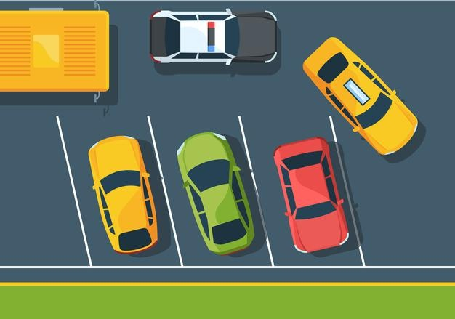

There are 4 cars parked at the car park. One car is about to leave. How many cars are left in the car park?

# 

You can create various word problems from a picture.

Chai and Chom look at the above picture.

There were 3 cars parked. One another car is parking. How many cars are there in the car parking?

Create word problems from the following pictures and orally tell them.



1)

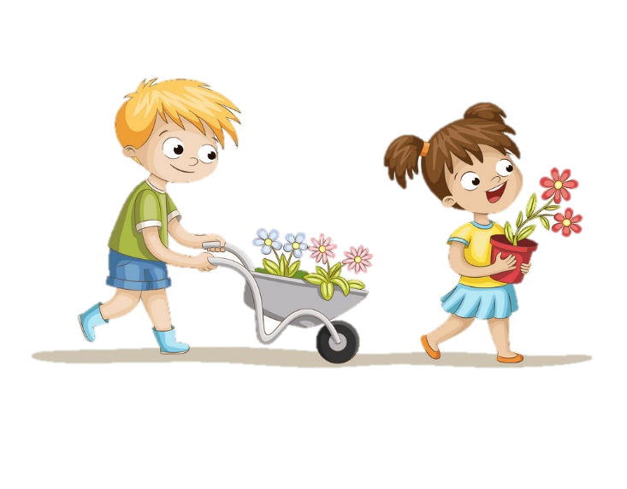

2)

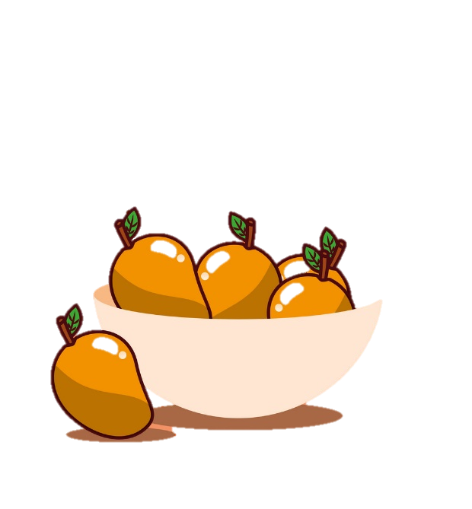

3)

**LET’S TRY!**

**What is the next fruit in this pattern?**





….………